

**STANDARDIZED STUDENT DRESS CODE**

**SHIRTS:** POLO-STYLE LIGHT GRAY OR BLACK SHIRTS (Plain, No Emblems/Writing)

* Gray or Black sweatshirts can be worn over polo-style shirts
* No long sleeve shirts worn underneath the polo-style shirt **PANTS:** UNIFORM-STYLE KHAKIS (No shorts, saggy pants, or cargo style pants) **SHOES:** SNEAKERS/TENNIS SHOES **(No solid blue or red shoes)**

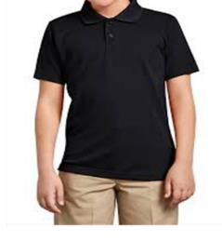  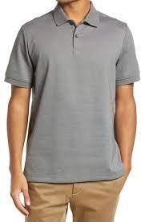

# Prohibited Items- In addition to those items in the Houston ISD Code of Conduct

* Communication devices or electronic equipment (cell phone, iPod, MP3, game devices Air Pod, Headphones)
* Backpacks, book bags, big purse
* Cosmetics and toiletries of any kind, other than sanitary napkins.
* Jewelry, Sunglasses, Head wear, ear, or nose piercings (NO BANDAGE GIVEN OUT)
* Outside items that are irrelevant to the learning process
* Hoodies, or coats
* Students cannot bring more than $10.00 to school each day.

All students’ belongings will be collected at check-in and will be distributed back to the student during check-out at the end of each school day.

Prohibited items shall be taken up and held subject to the DAEP Administrator. All students entering the building are required to go through a metal detector and are subject to random searches.

If a student arrives out of dress code, a parent/guardian will be contacted immediately. If parent/guardian cannot bring an acceptable change of clothes, DAEP will provide acceptable dress as supplies allow. All dress code decisions are at the sole discretion of DAEP administration and are final.

**CONSEQUENCES:**

**1st Offense –** Parent phone call and student can change into uniform provided by the school.

**2nd Offense –** One day added to assigned days, and a mandatory parent conference. **3rd Offense –** Three days will be added to assigned days, and a mandatory parent conference.



**Jeanette Echavarria, School Secretary Tamara Brown, Assistant Principal**

**Donielle Ryals-Gonzalez, Assistant Principal Tracy Cooper, Assistant Principal**